**Tittle : Product Sales Analysis**

***Introduction:***

In today's dynamic business landscape, understanding product sales is essential for any company aiming to thrive. A comprehensive analysis of sales data provides invaluable insights into consumer preferences, market trends, and the effectiveness of sales strategies. This sales analysis report delves deep into the intricacies of our product sales, examining patterns, identifying strengths, and pinpointing areas for improvement. By dissecting the data, we aim to equip stakeholders with actionable information, enabling informed decision-making and strategic planning. This analysis not only reflects our past performance but also serves as a compass guiding us toward a more successful future in the ever-evolving marketplace.

***Identify Products with Highest Sales:***

1. *Examine Sales Data:* Look at your sales dataset, focusing on the total sales figures for each product.

*#Import libraries*

import numpy as np

import pandas as pd

import seaborn as sns

import matplotlib.pyplot as plt

import warnings

warnings.simplefilter(action = 'ignore', category = **Warning**)

import os

for dirname, _, filenames **in** os.walk('/kaggle/input'):

for filename **in** filenames:

print(os.path.join(dirname, filename))

/kaggle/input/sales-product-data/Sales_August_2019.csv

/kaggle/input/sales-product-data/Sales_May_2019.csv

/kaggle/input/sales-product-data/Sales_February_2019.csv

/kaggle/input/sales-product-data/Sales_November_2019.csv

/kaggle/input/sales-product-data/Sales_January_2019.csv

/kaggle/input/sales-product-data/Sales_March_2019.csv

/kaggle/input/sales-product-data/Sales_September_2019.csv

/kaggle/input/sales-product-data/Sales_April_2019.csv

/kaggle/input/sales-product-data/Sales_July_2019.csv

/kaggle/input/sales-product-data/Sales_October_2019.csv

/kaggle/input/sales-product-data/Sales_June_2019.csv

/kaggle/input/sales-product-data/Sales_December_2019.csv

1. *Sort Products by Sales:* Arrange the products in descending order based on their sales figures. This can be done using spreadsheet software, data analysis tools, or programming languages like Python or R.



3. *Visualize the Data:* Create a bar chart or a similar visualization where products are represented on the horizontal axis and their corresponding sales figures on the vertical axis. This visual representation makes it easy to identify products with the highest bars, indicating the highest sales.

files = [file for file **in** os.listdir('../input/sales-product-data')]

for file **in** files:

print(file)

Sales_August_2019.csv

Sales_May_2019.csv

Sales_February_2019.csv

Sales_November_2019.csv

Sales_January_2019.csv

Sales_March_2019.csv

Sales_September_2019.csv

Sales_April_2019.csv

Sales_July_2019.csv

Sales_October_2019.csv

Sales_June_2019.csv

Sales_December_2019.csv

1. *Analyze the Chart:* Observe the products with the tallest bars in the chart. These represent the products with the highest sales.

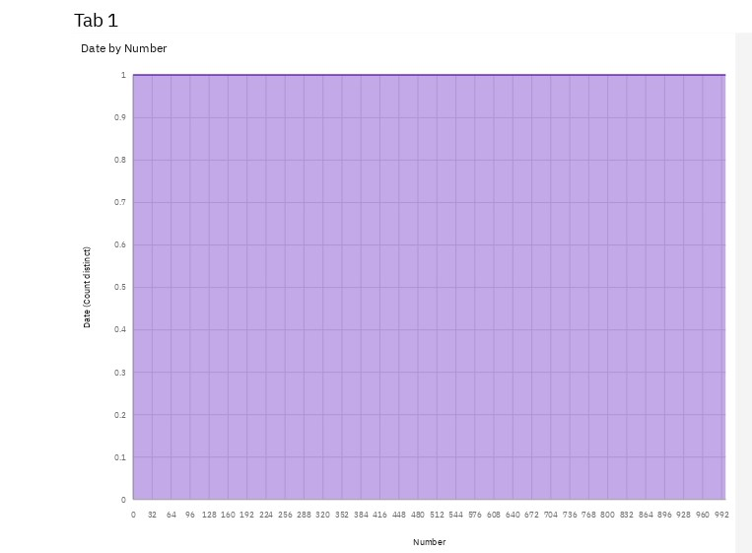

By following these steps and creating a visual representation of your sales data, you can quickly identify the products with the highest sales.

***Data Cleansing***

*#Merge the 12 months of sales data into a single file*

*#Create empty data frame for all data*

all_data = pd.DataFrame()

*#Make a loop for Concatenate the data*

for file **in** files:

data = pd.read_csv("../input/sales-product-data/" + file)

all_data = pd.concat([all_data, data])

all_data.head()

***Determine Peak Sales Periods:***

1. *Collect Time-Stamped Sales Data:* Ensure your sales data includes timestamps (dates and times) for each transaction.

import numpy as np

import pandas as pd

import seaborn as sns

import matplotlib.pyplot as plt

import warnings

warnings.simplefilter(action = 'ignore', category = **Warning**)

import os

for dirname, _, filenames **in** os.walk('/kaggle/input'):

for filename **in** filenames:

print(os.path.join(dirname, filename))

/kaggle/input/sales-product-data/Sales_August_2019.csv

/kaggle/input/sales-product-data/Sales_May_2019.csv

/kaggle/input/sales-product-data/Sales_February_2019.csv

/kaggle/input/sales-product-data/Sales_November_2019.csv

/kaggle/input/sales-product-data/Sales_January_2019.csv

/kaggle/input/sales-product-data/Sales_March_2019.csv

/kaggle/input/sales-product-data/Sales_September_2019.csv

/kaggle/input/sales-product-data/Sales_April_2019.csv

/kaggle/input/sales-product-data/Sales_July_2019.csv

/kaggle/input/sales-product-data/Sales_October_2019.csv

/kaggle/input/sales-product-data/Sales_June_2019.csv

/kaggle/input/sales-product-data/Sales_December_2019.csv

1. *Aggregate Data:* Group the sales data by specific time intervals, such as days, weeks, months, or seasons, depending on the level of detail you need.
2. *Create Time Series Visualizations:* Use line charts or bar graphs to visualize the sales data over time. The x-axis should represent the time intervals, and the y-axis should represent the total sales amount for each period.

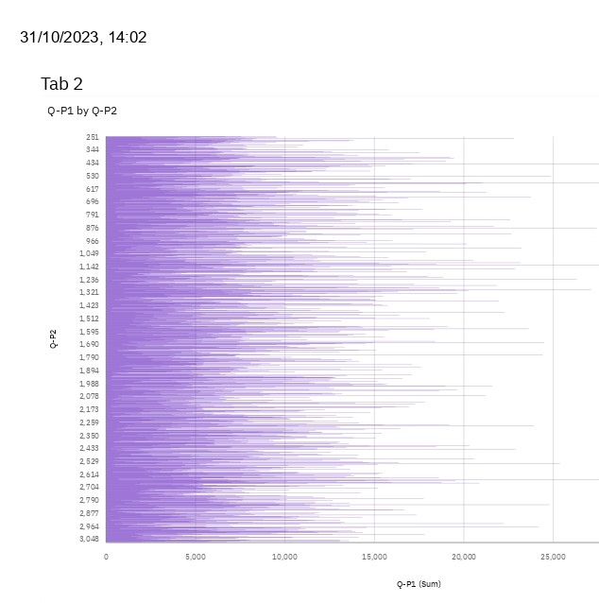

4. *Identify Patterns and Peaks:* Analyze the visualizations to identify recurring patterns or spikes in sales. Peaks in the chart indicate peak sales periods.

5. *Apply Statistical Techniques:* Utilize statistical methods like moving averages or trend analysis to smooth out fluctuations and identify underlying trends in sales data. This can help in pinpointing significant peaks.

6. *Compare Periods:* Compare sales data for different time intervals. For example, compare monthly sales to identify the month with the highest sales. Similarly, compare weekly data to identify peak days of the week.

7. *Consider External Factors:* Take into account external factors such as holidays, promotions, or special events. Peaks in sales might coincide with specific events or marketing campaigns.

8. *Use Data Analysis Tools:* If you're using data analysis tools like Excel, Google Sheets, or data visualization libraries in programming languages (such as Python's Matplotlib or R's ggplot2), these tools often have functions specifically designed for identifying patterns and peaks in time-series data.

***Utilize Advanced Techniques:***

1. *Predictive Analytics:* Use machine learning algorithms like regression analysis or time series forecasting (e.g., ARIMA, Prophet) to predict future sales based on historical data. This can help in anticipating trends and planning inventory accordingly.

2. *Customer Segmentation:* Implement clustering algorithms (such as k-means) to group customers based on their purchasing behavior. Understanding different customer segments can help tailor marketing strategies and product offerings.

3. *Market Basket Analysis:* Identify products frequently bought together using association rule mining techniques. This helps in optimizing product placement, cross-selling, and bundling strategies.

4. *Churn Analysis:* Analyze customer churn rates to understand customer retention. Identify factors leading to churn and implement strategies to retain valuable customers.

5. *Lifetime Value (LTV) Analysis:* Calculate customer lifetime value to understand the long-term profitability of different customer segments. This information can guide marketing budgets and customer acquisition strategies.

1. *Sentiment Analysis:* Analyze customer reviews and feedback using natural language processing (NLP) techniques to gauge customer sentiment towards products. Positive or negative sentiment can influence sales and product improvements.

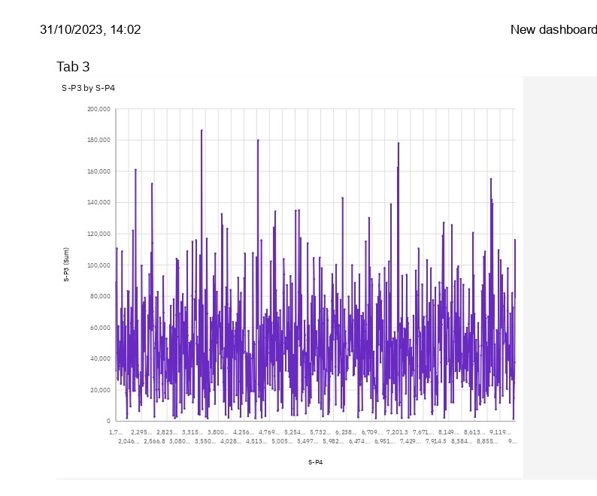

1. *Geospatial Analysis:* If sales data includes geographical information, use geospatial analysis to visualize sales patterns on maps. This can reveal regional preferences and assist in targeted marketing campaigns.

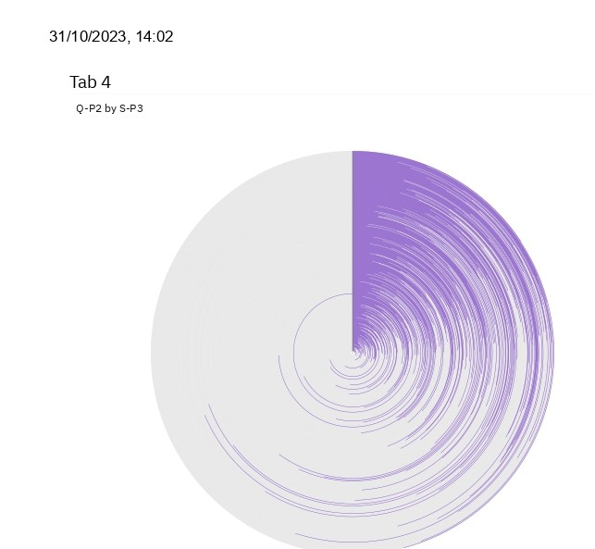

8. *A/B Testing:* Conduct controlled experiments (A/B tests) to compare different marketing strategies or product variations. This data-driven approach helps in understanding what resonates best with customers and drives higher sales.

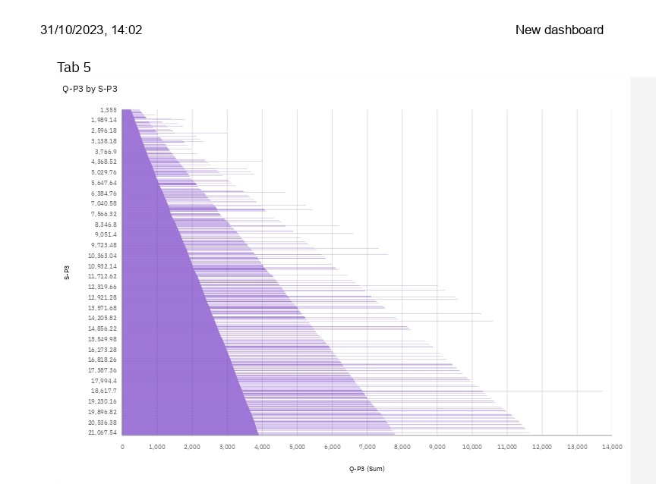



9. *Cohort Analysis:* Group customers based on their signup or first purchase dates. Analyze how different cohorts behave over time to understand customer loyalty, purchasing patterns, and revenue trends.



10. *Social Media and Web Analytics Integration:* Integrate social media and website analytics data with sales data to understand the impact of online presence on product sales. Track referral sources, user engagement, and conversion rates.

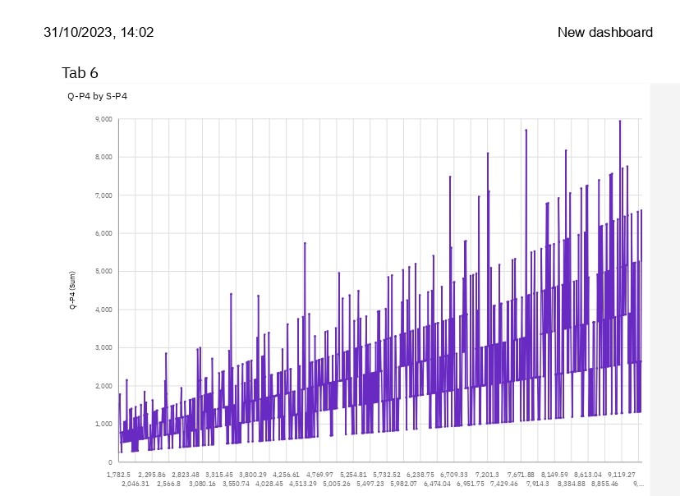

***Conclusion:***

The analysis of product sales provides valuable insights into the performance and dynamics of a business's revenue-generating activities. Drawing conclusions from such an analysis is crucial for making informed decisions and improving overall business strategy. Here are some key conclusions that can be derived from a product sales analysis:

***Identifying Top-Performing Products***: The analysis can highlight the products that consistently outperform others in terms of sales. This information is essential for focusing on high-impact items and optimizing inventory management.

***Seasonal Trends:*** Product sales analysis can reveal seasonal fluctuations in demand. Understanding these patterns is vital for effective inventory planning, marketing campaigns, and cash flow management.

***Customer Preferences:*** By examining the sales data, businesses can gain insights into customer preferences. This information can inform product development and marketing strategies, helping to better meet customer needs.

***Pricing Strategies:*** Sales data can shed light on how pricing affects sales volumes. It can help in adjusting pricing strategies to maximize both revenue and profit margins.

***Market Penetration:*** The analysis can also reveal how well a product is penetrating its target market. This information can guide expansion efforts and market-specific strategies.

***Competitive Analysis:*** By comparing sales performance with competitors, businesses can assess their market position and make adjustments to stay competitive.

***Inventory Management***: Understanding which products are slow-moving or fast-moving helps in optimizing inventory levels and reducing carrying costs.

***Marketing Effectiveness:*** The analysis can provide insights into the effectiveness of marketing campaigns. It helps to understand which strategies and channels are driving sales and which ones need adjustment.

***Customer Segmentation***: By analyzing sales data, businesses can identify different customer segments and tailor marketing efforts and products to specific customer groups.

***Forecasting and Planning:*** Sales data analysis is fundamental for creating accurate sales forecasts and business plans. This enables proactive decision-making and resource allocation.

***Thank You***